CENTRE FOR TRADE AND REGIONAL INTEGRATION
November 3, 2016

ACRONYMS
AC | Advisory Committee
AERC | The African Economic Research Consortium
AGOA | The Africa Growth & Opportunity Act
BIAT | Boosting Intra-Africa Trade
BIDPA | Botswana Institute for Development Policy Analysis
BLNS | Botswana, Lesotho, Namibia & Swaziland
BRICS | Brazil, Russia, India, China, South Africa
CBM/IBM | Component Business Model/International Business Machines
CFTA | Continental Free Trade Area
COMESA | Common Market for Eastern & Southern Africa
CTRI | Centre for Trade & Regional Integration
DTI | Department of Trade & Industry
EAC | East African Community
ECA | The Economic Commission for Africa
EPA | Economic Partnership Agreements
ESRF | The Economic & Social Research Foundation in Tanzania
LDC's | Least Developed Countries
NEPAD | New Partnership for Africa’s Development
NEPU | The Namibia Economic Policy Research Unit (NEPRU)
NGO | Non-Governmental Organizations
REC's | Regional Economic Communities
RSA | Republic of South Africa
SACU | Southern African Customs Union
SADC | Southern African Development Community
SDG | Sustainable Development Goals
SME's | Small Medium Sized Enterprises
TFTA | Tripartite Free Trade Agreement
TIPS | Trade & Industrial Policy Strategies (TIPS)
TRAPCA | Trade Policy Training Centre in Africa
UCT | University of Cape Town
UN | United Nations
UNCTAD | United Nations Conference on Trade & Development
UNDP | United Nations Development Programme
WBCG | Walvis Bay Corridor Group
WITS | World Integrated Trade Solution
WTO | World Trade Organization

CENTRE FOR TRADE AND REGIONAL INTEGRATION
November 3, 2016

1. Over the past two decades, the African integration project envisioned by its leaders since the Abuja Treaty in 1991, witnessed a revival. On October 2011, the First Summit of the Tripartite Heads of State and Governments launched the Common Market for Eastern and Southern Africa (COMESA), the East African Community (EAC) and the Southern African Development Community (SADC) Tripartite initiative. Under this initiative, the Tripartite Free Trade Agreement (TFTA), a free trade agreement among the 26 member countries of SADC, EAC, and COMESA, is currently being negotiated.

2. These developments are to-date, the most significant milestone towards African integration. At the continental level, all African regions are developing Action Plans around which governments, private sectors, and bilateral and multilateral development partners can mobilise. Continentally, Agenda 2063, provides a vision of “an integrated and prosperous and peaceful Africa, driven by its citizens and representing a dynamic force in the international arena”. Aspiration 2 of Agenda 2063 calls for an integrated, politically united continent with “accelerating progress towards continental unity and integration for sustained growth, trade, exchanges of goods, services, free movement of people and capital” .

3. More importantly, Agenda 2063 identifies the Continental Free Trade Area (CFTA) as one of seven pillars critical to ensuring an integrated and politically united continent.

4. Progress towards concretizing the CFTA needs to coordinate with development outside Africa. For developmental regionalism to materialise, the region needs to address numerous challenges. These problems include:
- The acute economic imbalances and inequalities that hamper regional integration in Southern Africa
- The inequitable distribution of influence between stronger states and poorer weaker states
- A constrained manufacturing sector, limited domestic markets as well as insufficient productive capacity and diversification
- The limited cross-border industrial linkage between countries
- The over-reliance on raw material production with limited value addition and beneficiation.
- Small growths in intra-regional investments that impede manufacturing activities
- A skills shortage at firm and policy making levels exacerbated by poor standards, quality and conformity infrastructure.
- An inadequate logistics infrastructure leading to high prices as well as unpredictable transport and logistics services
- The numerous non-tariff barriers that result in low levels of diversification in the intra-SADC trade

II. The Need for a Centre for Trade and Integration

6. The region needs a forward-looking research and policy support program to achieve developmental regionalism.

7. Historically, external continental forces have shaped the intellectual foundation for African trade and regional integration. A network of academics think-tanks, Non-Governmental Organisations (NGOs) and some researchers in the multilateral agencies have created an “epistemic community” of trade policy analysts reflecting the ideas and interests of the major business groups and developed countries. Their research and policy prescriptions, funded by large domestic commercial interests and bilateral and multilateral trading partners, fail to account for African realities adequately. This epistemic community has influentially declared the Doha Round "dead". They argue, the WTO is no longer relevant to the interests of the major business lobbies and has never been in line with the new 21st-century world economy (Ismail, 2011). This debate is particularly important for African countries many of which, still support completing the Doha Round.

8. The divergence in views between the African region and the major business groups as well as developed countries suggests a need for an alternative African narrative and a vision of Global Governance in the WTO that differs from the conventional perspective promoted by the US and its allies. This approach requires African nations and the BRICS countries to build a strategic coalition on the WTO and global governance. The African region needs greater coherence and a common strategic approach to both African integration and the world trading system.

9. The African region needs a forward-looking research and policy support program grounded in African realities to deal with the current changes in the trade agenda adequately. Such a program needs to focus on the rule-making processes at global and regional levels as well as inform the policy reforms that will streamline legal, institutional and regulatory frameworks in a manner that fosters regional and international competitiveness. Likewise, the regulatory frameworks should have spill-over effects on productive and supply capacity. The requisite program needs to have support mechanisms for building and sustaining a coalition comprised of governments, private sector actors, academics, and civil society actors that can pressure for needed reforms.

10. CTRI will serve as a platform for capacity development, policy research, knowledge sharing, information exchange and international collaboration in the areas of international trade and regional integration. The Centre will promote African integration through an intensive applied policy research and policy support programme. The institution will train decision makers and other key players, facilitate and strengthen regional exchange, foster collaboration, promote knowledge sharing and South-South learning. The Centre will also help build peer-pressure coalitions of stakeholders and relevant government bodies that will play a vital role in deepening regional integration.

11. The Centre will endeavour to achieve these goals:
(i) By facilitating analysis and designing rules and regulations that foster competitiveness. The centre will also (ii) shape policy design and support implementation policies that both ensure equitable benefit allocation and address any adverse distributional consequences of integration.

III. The Mandates and Functions of the Centre

12. The Centre will be a vehicle for articulating and promoting the African integration vision by leveraging South Africa's strategic position and economic strength on the continent. The Centre will help address the insufficient attention placed on nurturing two-way trade between South Africa and the rest of Africa by prioritising actions that capitalise on the size and complexity of the South African economy to promote African integration.

13. The Centre’s work will cover four themes:

- First:
CTRI will inform African developmental regionalism through a focus on factors that nurture the trade-development nexus in Southern Africa and the rest of the continent
- Second:
CTRI will seek to help the region organise itself to better influence the WTO's governance, and overall engender trade rules that are supportive to African developmental regionalism
- Third:
CTRI shall also inform policy efforts to create a modern age industrialisation that is beneficial to both larger and smaller economies as well as vast and small producers in Southern Africa
- Fourth:
CTRI will leverage Southern African competitiveness to deepen regional integration

IV. The Centre's Approach

14. The Centre’s work is expected to fill niches in both South Africa as well as the SADC region, and possibly extend to the rest of the continent in the future.

15. Practically, the Centre will work in the interface of four thematic concerns:
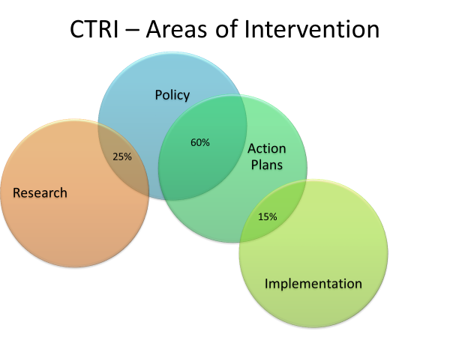

- Trade and regional integration
- The nexus between research and policy
- Policy and Action
- Action and implementation.

16. The Centre will engage in and sponsor policy-oriented research across a broad range of issues relevant to developmental regionalism. It will partner with various entities to collect data, compile evidence and analyse issues related to trade, regional industrialisation and cross-border infrastructure, of relevance to Southern Africa. It will tease out issues from the literature and build up the evidence base for policy making on developmental regionalism. In the process, the Centre will also seek to strengthen the capacity of trade practitioners in the sub-region by designing and facilitating workshops and relevant policy research and training programmes.

IV.1 Trade Policy Research Practice Networks

17. The Centre should provide timely and relevant analysis, and strategic advice to advance sustainable developmental regionalism in Southern Africa by nurturing a sound policy and research interface. CTRI should have a department to address the nexus between research and policy directly.

18. The department will have as an objective two goals:
- Nurturing the policy and research interface through demand-driven policy research
- Empowering policy makers with the capacity to translate research into policy

19. The department will address a series of challenges. These issues include:
- A critical lack of understanding by researchers of the policy process, and the role their research can play in shaping policy
- The undersupply of policy-relevant research, and data needed to generate analysis
- The lack of knowledge by Trade negotiators and policymakers of policy relevant research
- Policy-makers’ incapacity to translate research into policy

20. The department will endeavour to redress the challenges through five policy strategies. These directives will consist of:
- Cultivating a pool of credible specialist able to advocate policies
- Creating a network of relevant mobilizers at all levels of the policy process
- Nurturing institutional incentives that change the behaviours of policy-makers
- Retaining and partnering with appropriate institution willing and able to champion policy proposals on developmental regionalism
- Capitalising on researchers and networks on the continent and across the world that can assist in providing timely and strategic analysis that advances sustainable as well as developmental regionalism
Box 2: Trade Policy Research Network for Africa developmental integration 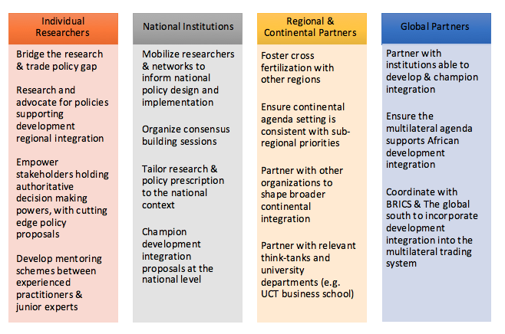

IV.2 Trade Practice Networks to Support Policy Reform and Projects

21. The CTRI’s second focus will consist of policy implementation support and actions to unlock new investment opportunities. CTRI will facilitate dialogue and networking among multiple stakeholders and across disciplinary fields on the conceptualization and implementation of the African developmental regionalism. Through its programming efforts, CTRI will emerge as a centre of excellence that provides cutting-edge, timely knowledge and expert backstopping support that enhances understanding of developmental regionalism. CTRI will nurture and support issue-specific trade practices, and a pool of regional and international experts committed to supporting policy formulation and implementation for countries, RECs and private sector operators.

22. A coordinated policy reform platform will function as a pillar of support to policy efforts. The principles will serve as an effective coordinating mechanism for programs and policies at the national, corridor, and regional levels. The platform will aim to:
- Support policy implementation efforts and actions to unlock new investment opportunities
- Promote balanced growth across the Southern African Customs Union (SACU)
- Develop a platform focused on regional value chains to better balance commerce between Southern African Countries
- Support a trade practice network that fosters cross-border business facilitation

23. The policy reform's programming will centre around five policy strategies.
- Developing policies to nurture a diversified export base that:
- Leverages South Africa’s scale as a demand engine and gateway for developing robust global value chains and diversifying exports
- Harmonises border procedures along key corridors to foster two-way trade beneficial to all countries
- Establishes policies to address the challenges faced by firms seeking to grow to scale
- Strengthening the linkages between Southern African multinational corporations and producers in other southern African countries
- Building and maintaining an inventory of comprehensive, comparable and up-to-date statistical information on SMEs.
- The strategy will address the obstacles to building linkages. Such an approach could consist of redressing information barriers among other initiatives.
- Improving information flows on potential suppliers, purchasers and technology partners.
  - Such an action could include improving information flows on potential suppliers, buyers and technology partners.
- Fostering inter-firm subcontracting that enables regional producers to act as suppliers to South African firms to help establish collaborative supply relationships

Box 3: A Platform to promote two-way trade
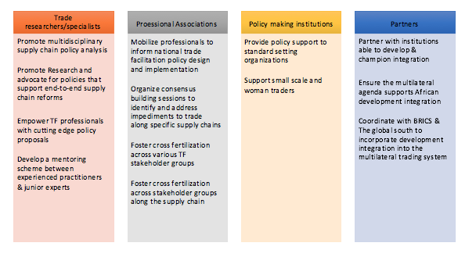

- Box3 summarises CTRI's platform for supporting more balanced trade between Southern African countries. It will capitalise on best practices to boost sustainable growth in two-way trade between African nations. The primary components of the network will entail (i) Trade specialists/researchers (ii) product-specific professional associations, (iii) national and regional policymaking institutions (including standard setting bodies), and (iv) regional, continental and global funding agencies.
24. CTRI’s should also support a trade practice network that fosters cross-border trade facilitation. CTRI could, therefore, focus on three domains:
- Provide policy support that addresses the logistical impediments along the supply chains and promotes SME integration in regional and global value chains. Such an approach could consist of supporting design and implementing sector or product-specific processes that meet the needs of smaller businesses.
- Strengthen regional border harmonisation and operation efforts:
  - Actualized through support to Customs’ modernization programs throughout Southern Africa
  - Backed by working groups that harmonise documents and procedures at borders
  - Developed through a centralised system that allows for a one-stop trade information portal as a stepping stone to a full Single Window
  - Extended through the One Stop Border Posts and coordinated through Border Management
- Streamlining freight in the region including support to a regional freight billboard, policy support to SACU and SADC logistics liberalisation efforts

Box 4: A Cross-Border Trade Facilitation Network to Complement Investments in Cross-Border Infrastructure
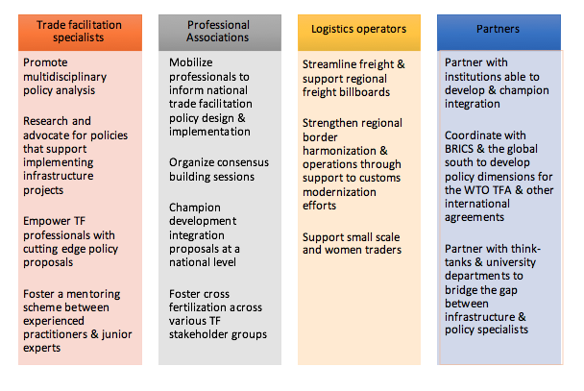
- Box 4, summarise the main features of such a platform to support cross-border trade facilitation. Such a platform shall support policy reforms that would complement investment in cross-border infrastructure. Such support would either enhance the return on these investments or unlock opportunities in new investment in infrastructure and productive sectors.

IV.3 Training and Capacity Development of Trade Practitioners

26. The Centre’s third operational focus will be to build the capacity of trade and regional integration practitioners. Numerous assessments have offered a comprehensive diagnostic of the biggest constraints to trade integration, developed actions to address these constraints, informed donors on trade-related assistance, and supported governments in placing regional commerce at the heart of national development plans. Unfortunately, removing these restraints and boosting competitiveness has yet to be achieved. CTRI's third operational approach will resolve these constraints with attention to two elements:
- Building the capacity of trade and regional integration practitioners
- Equipping current initiatives with an adequate coverage of the trade and integration agenda

27. CTRI's policy strategies will consist of:
- Incorporating trade into national budget and public expenditure allocation
- Enhancing synergies with export and sector strategies by bringing on board national expertise and know-how within and across different agencies
  - This approach will consist of aligning the trade agenda with national development processes and donor cycles
- Developing a package of training materials and resources that improve, coordinate and articulate regional skills development in support of industrialisation
  - This strategy will consist of training in technical barriers to trade, with sanitary and phytosanitary barriers prioritised initially
- Arranging partnerships with training institutions in Southern Africa (e.g. TRAPCA)
  - Such programs will need to highlight a business perspective. For example, the UCT business school offers such opportunities through, among others the “Managing Infrastructure Reform and Regulation” as well as through its Master of Commerce Degree program. This partnership can also be established with institutions in BRICS countries and the global south. An important aspect of the training programs will be a collaboration with business schools and other professional schools such as the UCT business school.

V. Governance and Management

28. CTRI will be an independent South African NGO. It will enter implementation arrangements with a range of implementing agencies. To expedite the operationalization of the Centre, CTRI will negotiate a one-year, non-renewable hosting agreement contract with the UCT/Law School.

Board

29. An active and independent Board is essential to CTRI. It will help secure adequate funding, guarantee its founding principles guide its activities and ensure the Centre’s adaptation/innovation as it proactively strives to remain relevant. The CTRI Board is responsible for the following:
- Providing strategic guidance, setting the mission, purpose and objective of the Centre as well as approving the business plan, and hiring the Chief Executive Officer.
- Providing strategic oversight of the Centre, ensuring accountability and securing financial integrity. Such an approach would include undertaking regular CTRI performance evaluations, approving annual work plans, budgeting and maintaining procedure manuals as well as monitoring and assessment frameworks.
- Providing and maintaining the prestige and public image of CTRI

30. It is crucial that the board’s focus remains on oversight and not on the day to day activities best handled by management. Maintaining this balance will streamline accountability processes. In the same breath, the board needs to be cautious not to depend too heavily on management to the extent that it undermines strategic leadership at the level of the Board. In striking this balance, it is important for the Board to develop and own general strategies. Such an approach is critical even in instances where the CEO proposes strategies. It is important that all levels have a clear understanding of the separation between their roles as well as clear communication pathways between the Board and the Staff.

31. The Board should have a mix of skills: this includes content and context knowledge, as well as expertise in the areas of management, finance and HR.

The CTRI Board should comprise of:
(i) A financial contributor from the UNDP, the Department of Trade and Industry of South Africa and any institution able to contribute at least USD100K annually or a cumulative amount of at least USD300K over a span of five years;
(ii) Members at large that represent the perspective of various stakeholders’ groups, including national governments, professional associations, the private sectors and civil society.
(iii) A Chief Executive Officer that is an ex-officio member of the Board.
(iv) The Board appoints members of the Advisory Committee, based on proposals from the CEO of CTRI. The chairperson of the Advisory Committee would be a non-voting ex-officio member of the Board.

Advisory Committee:

32. The Advisory Committee will advise the CEO on programs and activities that should be undertaken to ensure alignment with the CTRI mission. The Advisory Committee shall be independent of the Board. Members of the AC should include the CEO and individuals selected through pre-approved criteria determined by the Board and proposed by the CEO. The AC should comprise of distinguished persons (eminent scholars, professionals, the private sector as well as present and former public officials) that add to the prestige of the Centre. The Centre will have a second category of expert advisors. These actors will bring credibility and expertise on a range of subject matters and activities. This organisation of agents will be particularly useful during the initial years as the Centre rides on the credibility and expertise of those associated with its name.

CTRI Management
33. CTRI management will act as the third layer of Governance. Their responsibilities will comprise the day-to-day administration of the Centre. CTRI's CEO will head CTRI’s management supported by a professional and administrative staff. The Centre will also feature a network of professionals and partner institutions and will appoint its Executive Director through the Board.

The African Union. (Accessed on 25 October 2016). Vision and Mission. African Union website: http://www.au.int/en/about/vision
African Union. Africa Trade Week 2016. African Union website: http://www.au.int/en/ATW2016
Evenett & Jara, 2013
Evenett & Jara (2013)
Ismail (2011)

